User Interface Complexity

User Modeling

Human Computer Interaction

Mirela Gutica

January 25, 2010

- Bayesian Theorem and Models
Bayesian models are currently used in Artificial Intelligence (AI), cognitive science, decision systems, expert systems, pedagogical agents, and Microsoft Office applications.
The Bayesian theorem was discovered by Reverend and mathematician Thomas Bayes (1702 – 1761), published posthumously, and accepted by Laplace in 1781. Bayes argued that the estimated probability for a future event is based on measurements of data, a model for these measurements, and a model for our prior beliefs about the system. According to Heckerman, “the Bayesian probability of an event x is a person’s degree of belief in that event” [3]. Figure 1 illustrates the Bayesian theorem.
Bayesian networks are graphical models used for the representation of probabilistic relationships among a set of variables. Bayesian networks are represented with directed acyclic graphs. The nodes represent the random variables, the directed edges represent the relationship between nodes and conditional probabilities are associated to each variable with respect to its parents. Figure 2 represents an example of a Bayesian network for detecting credit-card fraud offered by Heckerman in his Tutorial on Learning with Bayesian Networks [3]. The conditional probabilities can be physical when determined from data, or Bayesian when determined from prior knowledge alone. Heckerman stated that there was found a direct relationship between Fraud and Gas and between Fraud, Age and Sex, and Jewelry [3]. The Bayesian network was generated by drawing arcs from cause variables to their immediate effects. The local probability distributions P(x_{i}| pa_{i}) described the relationships between variables. In Heckerman’s example all variables were discrete.

- Key Issues with User Modeling
A system is deterministic if produces the same output for a given input. Many real-life systems are required to be deterministic; however, in some cases this requirement cannot be employed. A stochastic system is a non-deterministic system that produces different outputs on exactly the same inputs. Stochastic systems are dominated by uncertainty.
User modeling is a field of Human Computer Interaction (HCI) and AI concerned with creation of “interface agents” or “intelligent agents” [5] that can predict the user’s future actions based on the current state of the system, the user’s profile, and previous actions and prior beliefs. User modeling is used to identify the users’ needs based on a decision model that takes into consideration the users’ beliefs, intentions and goals. Uncertainly is a key aspect of user modeling because the same situation can induce a variety of different outputs depending on several factors, for example the users’ emotional or mental state [2, 4, 5].
Another important issue in user modeling is related to complexity. Horovitz et al. were concerned with the complexity associated with temporal reasoning and, Albrecht and Zukerman observed concerns that were raised in their research by Lekakos and Giaglis related to time complexity, and by Domshlak and Joachims regarding tractability during model construction [1, 4].
The dynamic nature of user modeling data was also observed as a challenge by Albrecht and Zukerman, Conati and Zhou, and Horovitz et al. [1, 2, 4].
Bayesian models are used in user modeling as probabilistic models for computing the likelihood of a certain event to happen. Horovitz et al. identified several areas of research that used Bayesian models for user modeling: multiattribute utility models employed in the Pathfinder pathology diagnostic system, models used for interpreting patterns of evidence by flight engineers at the NASA Mission Control Centre, models of pilots’ goals for commercial aircrafts, and models for inferring the drivers’ goals when navigating in traffic [4].
An important area of research is education. Conati and Zhou conducted a study for assessing the students’ emotional reactions during interaction with educational games. In their study, they researched intelligent “pedagogical agents” based on Dynamic Decision Networks (an extension of Bayesian networks) to represent the relationships between a student’s emotional states [2].
Bayesian networks are not the only probabilistic models used for user modeling. In their special report on statistical and probabilistic methods for user modeling, Albrecht and Zukerman identified other statistical and probabilistic models used for user modeling: the Markov Decision Processes hybrid model proposed by Chickering and Paek, the Item Response Theory developed by Guzman, and Decision Trees used to perform on-line adaptation for individual users by Paek and Chickering [1].
According to Albrecht and Zukerman there are two main approaches employed in statistical user modeling: content-based and collaborative. The content-based approach uses previous behavior to predict future user’s actions, while the collaborative approach generates predictions based on other “like-minded” people [1]. Both approaches have limitations; in the case of content-based approaches, “the features selected when building a contend-based model have a substantial effect on the usefulness of this model”, and in the case of collaborative approachs, predictions are too general and don’t apply to the individual user [1]. On the positive aspect, Albrecht and Zukerman argued that the current computational power and the vast electronic information about the users’ actions create an excellent opportunity for harnessing statistical data and designing user models [1].
Intelligent agents that predict the users’ needs have several challenges. Horovitz argued that systems governed by uncertainty are unreliable and inadequate in terms of costs and benefits [5]. He proposed a mixed-initiative approach to user modeling: systems that contain interface agents and also involve the user in an active way by promoting collaboration between the interface agent and the user. In his paper, Horovitz identified twelve key principles that should be taken into consideration in user modeling. He proposed an approach that combined probabilistic user modeling and adaptable interfaces [5].

- Example of a User Modeling System: The Lumière Project
An example of research in user modeling for improving the user’s assistance and help was the Lumière Project, designed and implemented at the Microsoft usability laboratory between1993 and 1997. The Lumière project used probability distributions over users’ goals to provide automated services for help. The purpose was to create an intelligent prototype that determined the users’ needs, goals and intentions from user profiles, context, events in the interface, and words from the users’ queries. A Bayesian model was used to infer the likelihood that a user needed help and the type of help that was needed [4].
After identifying the relevant variables and the relationships between them, discrete Bayesian networks were constructed. Figure 3 illustrates a portion of a Bayesian user model used in the Lumière study that infers the likelihood that a user needs help based on his recent activities and the user’s profile. According to this Bayesian model, a user is likely to need assistance after a pause in activity. The need for assistance influences the probability of detecting recent menu surfing. However, a pause in activity can also be the result of other events, for example the fact that the user got distracted [4].
Creating a static Bayesian model is unrealistic because the user’s goals change over time. After studying several approaches, Horovitz et al. developed a dynamic Bayesian model that employed the conditional probability of time-indexed actions p (E _{i,t} | Goal t₀). Parametric, linear, and exponential functions were used to calculate the decay of the conditional probabilities over time [4].
The Lumière study included an experiment conducted in the Microsoft’s usability laboratory. The experimental study used the Wizard of Oz design with experts acting as a “help system” for users. Figure 4 illustrates the experiment: an expert, sitting in an acoustically-isolated separate room had access to a user’s monitor and offered help. After the experimental study, Horovitz et al. came to two conclusions: experts can identify the users’ needs and “poor advice is costly to users” [4].
In order to implement user modeling, a software application should give access to the users’ actions. Therefore, a special version of Excel was developed for the Lumière Project. The special version was designed to gather information regarding mouse and keyboard events, activities involving dialog boxes, and the status of the data structures manipulated by the user. Architecturally, the system incorporated low-level atomic events associated with the users’ activities and an event language containing a set of operators designed to analyze and interpret these events. The atomic events were used to map the high-level actions performed by users. The system used data collected from events as input for the Bayesian model. A competency profile was maintained in the operating system registry [4].
When the user selected help, the Lumière system generated a list with a new ordering of relevance of topics, and a set of probabilities (see Figure 5). A window appeared on the screen after the inferred likelihood that the user will desire assistance exceeded a user-set threshold. The user could easily adjust the threshold with a slider control (see Figure 6) [4].

- Conclusions and Future Directions
User modeling is an important field of research in the academic world and industry with several statistical, probabilistic, and mixed methods being studied and proposed [1, 2, 4, 5]. Members of the HCI community are optimistic that human-computer interaction can be improved by user modeling [1, 6].
Several directions should be mentioned: Conati and Zhou expressed their intention to refine their model by including personality assessment [2], Horovitz extended his research from probabilistic Bayesian models to mixed-initiative approaches [4, 5], and Albrecht and Zukerman observed the extension of predictive statistical models to new domains and tasks [1].
It is hard to predict the future of user modeling based on my readings, but I can state that the field is vibrant and user modeling will benefit from recent technological advances and current research initiatives.
References

- Albrecht D. & Zukerman I. (2007) Introduction to the special issue on statistical and probabilistic methods for user modeling Published online: 13 February 2007 © Springer Science+Business Media B.V. 2007 Retrieved from Internet October 20, 2007 from http://www.springerlink.com/content/2m142x388237w62x/fulltext.pdf

Albrecht and Zukerman offered an overview of the papers published in Volume 17 of User Modeling and User-Adapted Interaction (UMUAI) journal. They identified challenges related to user modeling: complexity, efficiency, limitations of current modeling approaches, and the dynamic nature of data.

- Coneti C. and Zhou Z. (2002) Modeling Students’ Emotions from Cognitive Appraisal in Educational Games. Proceedings of the 6th International Conference on Intelligent Tutoring Systems. Pages 944 – 954. Retrieved July 4, 2007 from ACM Portal http://portal.acm.org/citation.cfm?id=743918&dl=&coll=&CFID=15151515&CFTOKEN=6184618

In their paper, Coneti and Zhou presented a study of a pedagogical intelligent agent incorporated into an educational game and designed to asses the students’ emotional reactions. The agent used a probabilistic model based on Dynamic Decision Networks (DNNs).

- Heckerman D. (1995) A Tutorial on Learning With Bayesian Networks Retrieved from Internet on October 20, 2007 from ftp://ftp.research.microsoft.com/pub/tr/tr-95-06.pdf

Heckerman offered a tutorial on Bayesian networks and techniques used for data representation and analysis.

- Horvitz, E., Breese, J., Heckerman, D., Hovel, D., & Rommelse, K. (1998). The Lumière Project: Bayesian user modeling for inferring the goals and needs of software users. Proceedings of the Fourteenth Conference on Uncertainty in Artificial Intelligence, 256 - 265 Retrieved from Internet on October 20, 2007 from http://research.microsoft.com/%7Ehorvitz/Lumière.HTM

Horovitz et al. presented the Lumière Project, an intelligent prototype for Excel developed at Microsoft usability laboratory between 1993 and1997. The prototype was based on a Bayesian model and was developed to determine the users’ needs, goals and intentions from context, events in the interface, and words from the users’ queries. The paper targeted experts in user modeling offering technical and mathematical details.

- Horvitz, E. (1999) Principles of Mixed-Initiative User Interfaces. Proceedings of CHI '99, ACM SIGCHI Conference on Human Factors in Computing Systems, Pittsburgh, PA, May 1999. Retrieved from Internet on October 20, 2007 from
http://research.microsoft.com/%7Ehorvitz/UIACT.HTM

Referring to expected costs and benefits, and uncertainty issues, Horovitz identified issues related to intelligent agents for user modeling. He proposed mixed-initiative approaches combining probabilistic models and adaptable interfaces.

- Horvitz, E. (2007) Lumière Project: Bayesian Reasoning for Automated Assistance Retrieved from Internet on October 20, 2007 from http://research.microsoft.com/~horvitz/lum.htm

In this paper, Horovitz presented the Lumière Project in a simpler format targeting a less technical audience than paper [4]
Appendix

The Bayesian theorem is formulated as follow:

P (H|X) = (likelihood * prior)/ normalized constant or

P (H|X) = (P(X|H)* P(H)) / P(X)

Where: X is the data
P (H|X) is the posterior probability of H conditioned on X
P(H) is the prior probability of H
P(X|H) is the posterior probability of X conditioned on H
P(X) is the prior probability of X (or normalized constant)
Figure 1 The Bayesian theorem

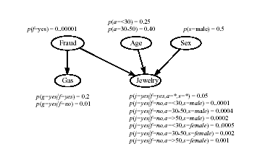

Figure 2 [3] (Heckerman, 1995, p. 13) A Bayesian network for credit-card fraud detection

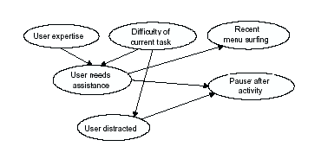
Figure 3 [4] (Horovitz et al., 1998) A portion of a Bayesian user model for inferring the likelihood that a user needs assistance, considering profile information as well as observations of recent activity.

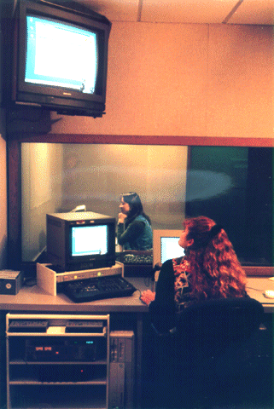

Figure 4 [6] (Horvitz, E. 2007) An expert, sitting in an acoustically-isolated separate room had access to a user’s monitor and offered help.

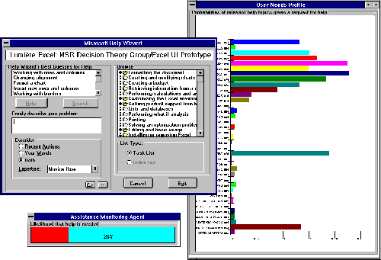

Figure 5 [6] (Horvitz, E. (2007) The Lumière system created a list with a new ordering of relevance of topics. In the background, probabilities were generated.

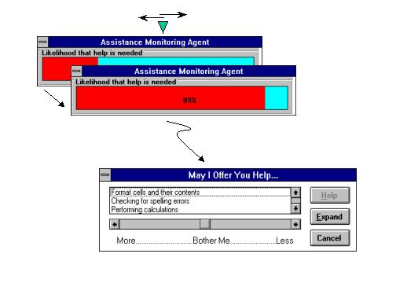
Slider control that adjust the level of assistance desired by the user

Figure 6 [6] (Horvitz, E. (2007) The user can easily adjust the threshold with a slider control.

